First FAO Global Exhibition: From Seeds to Foods
Theme: Better Production, Better Nutrition, a Better Environment and a Better Life, leaving no one behind
Date: 10 to 13 October 2025
Venue: Park of Porta Capena, Rome, Italy

Introduction
The Food and Agriculture Organization (FAO) is a specialized agency of the United Nations that leads international efforts to defeat hunger. Its goal is to achieve food security for all and make sure that people have regular access to enough high-quality food to lead active, healthy lives. With 195 members, 194 countries and the European Union, FAO works in over 130 countries worldwide.

For eight decades, FAO has led efforts to improve productivity in crops, livestock, fishery and forestry. The FAO Strategic Framework 2022-31 prioritizes transforming agrifood systems to be more efficient, inclusive, resilient and sustainable, leaving no one behind, and contributes to the Sustainable Development Goals (SDGs).

Rationale
To commemorate the 80th anniversary of FAO’s founding, a yearlong celebration was launched that is providing a unique opportunity for FAO, Members and partners to take stock of the many historic achievements of the Organization and together reflect on how to deploy its unique comparative advantage to address today's and future challenges to ensure food security and nutrition for all.

The First FAO Global Exhibition: From Seeds to Foods (Global Exhibition) with the theme Better Production, Better Nutrition, a Better Environment and a Better Life, leaving no one behind is proposed to be held from Friday, 10 October to Monday, 13 October 2025, as part of the fifth edition of the World Food Forum, and to constitute a milestone moment in the 80th anniversary celebrations. This exhibition is an opportunity for FAO, Members and partners to showcase achievements in the agricultural sector, sustainable and resilient agriculture practices and demonstrate successful initiatives to produce more with less.

The four-day Global Exhibition will consist of displays and exhibitions of the elements and activities across the entire value chain of agrifood systems – from seeds to foods – covering field crops, horticulture, livestock, forestry and fisheries. It will showcase, among others seeds, stocks, new varieties, seed systems, management systems, application of science and modern technologies, innovations in fertilizer, conservation, protection, food safety, and culinary experiences through food tasting.

Objectives
The main objectives of the Global Exhibition are to:
- Provide a platform for FAO, Members, and partners to showcase their achievements across value chains, sustainable and resilient agriculture practices and initiatives to produce more with less;
- Highlight the role of science and innovation, together with traditional knowledge and practices, in agrifood systems;
- To share knowledge among Members and other stakeholders;
- To increase the visibility of FAO and its role as a global leader in addressing hunger globally; and
- To raise awareness on the power of partnerships to continue to fight hunger and malnutrition.

Venue
The exhibition will take place in the Park of Porta Capena near FAO on the Terme di Caracalla Road, see the map below.

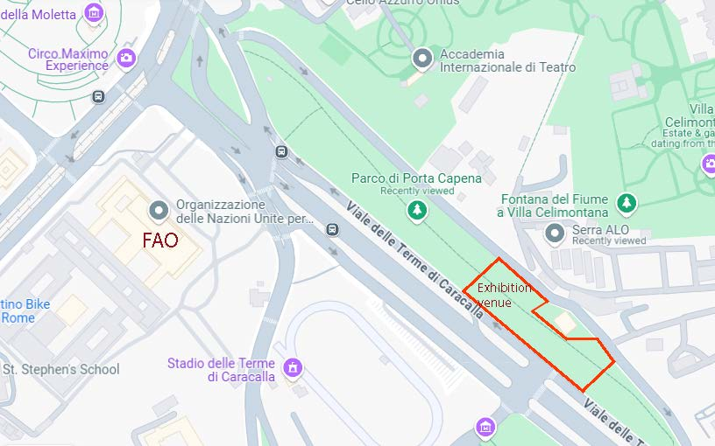

Overview of the exhibition
There will be four main sections of the exhibition, as follows:
- Section A: Agriculture Products
- Section B: Agriculture Technologies
- Section C: Agriculture Foods
- Section D: Promotion Activities, opening ceremony will take place here

Section A: Agriculture Products
This section will focus on showing key agricultural information of countries’ crops, livestock, fishery and forestry, special agriculture products (SAPs), agriculture success stories and best practices, significant milestones, etc. All six FAO regions will be represented: Africa (RAF), Asia and the Pacific (RAP), Europe and Central Asia (REU), Latin America and Caribbean (RLC), Near East and North Africa (RNE), and North America (LOW).

FAO Regional Offices under the leadership of Assistant Directors-General and Regional Representatives, with the support of FAO Liaison Offices and in collaboration with the Plant Production and Protection Division (NSP), will be responsible for Section A. They will coordinate the preparation with FAO’s Country Offices in their respective region to ensure diversity, representativeness and quality of the exhibit from their regions.

The total area allocated to each region will be communicated in due course.

Section B: Agriculture Technologies
Various technologies will be displayed in this section, which will include:
- Plant production and protection technologies, e.g. crop seeds and seedlings, cropping systems, fertilizers, pesticides, etc. – led by NSP/CJN
- Livestock production and animal health technologies, e.g. animal stocks, breeding, vaccines, antimicrobial resistance (i.e. AMR), etc. – led by NSA/CJW
- Forest production and protection technologies, e.g. forest seeds and seedlings, management, silviculture, forest fire prevention, pesticides, protection, conservation, etc. – led by NFO.
- Fishery and aquaculture technologies, e.g. fishery stocks, aquaculture, aquatic protection, etc. – led by NFI
- Resource use and preservation technologies, e.g. reclamation of salt-affected land, water use efficiency, resources preservation, etc. – led by NSL/OCB
- Agriculture mechanization and digitalization technologies, agriculture machineries, equipment, digitalization, etc. – led by NSP/CSI
- Post-harvest and food processing technologies, e.g. post-harvest, storage, food processing and preservation, etc. – led by ESF/CJW
- High technologies, e.g. biotechnologies, bioinformatics, AI nanotechnology, etc. – led by OIN

FAO Divisions, Offices and Centres will be responsible for Section B, with the support of NSP. They will ensure collaboration with partners and relevant Divisions/ Offices/ Centres within FAO.

Section C: Agriculture Foods
This section will showcase the foods (final product) produced from plants, crops, animals, and fish; and cooking demonstrations and food tastings will take place here. This section will cover four elements:
- Diversity of foods, various kinds of foods, fresh foods, package foods, snacks, etc. – led by ESN.
- Functional foods that provide health benefits beyond basic nutrition – led ESN
- Opportunity foods, also referred to as forgotten foods, that encompass tens of thousands of biodiverse plant and animal species that offer us different food options, provide valuable nutrients and support resilient agriculture – led by NSP/PSU
- Culture of foods that showcase different cultures and traditions across the globe – led by OCC/GIAHS

Section C will be led mainly by Divisions, i.e. ESN, NSP, PSU, OCC and GIAHS and they will collaborate with relevant divisions and partners.

Section D: Promotion Activities.
Envisioned as a Central Stage, Section D would be a gathering place for the opening ceremony that will feature the DG’s opening remarks and statements from invited VIPs. Other activities will be organized to attract participation and attendance, such as: live shows, music, cultural activities, quizzes, performances, etc.

Section D will be led by OCC/OYW in collaboration with other divisions.

Exhibitors
Exhibitors will include FAO, Members and partners – including research and academic institutions, civil society organizations, private sector, youth, Indigenous Peoples and women's groups, and others.

During the event, exhibitors will be assigned space based on the Sections described above. Exhibitors will use various means such as digital screens, posters, displaying products, machinery, equipment and tools, live demonstrations and food tastings, etc. Due to the complexities of transporting and importing seeds, alternative methods for demonstrating seeds, seedlings and seed value chain, including digital tools, should be used.

Organization
- The strategic oversight of the event (steering group) will be undertaken by FAO’s cross-divisional and cross-office Directors and Regional Representatives (ADG/RRs) led by DDG-Bechdol and NSP Director. The steering group consist of ADG/RRs, Directors of OIN, OCB, OYW, OCC, CJW, CJN, PSU, NFI, NFO, NSL, NSP, NSA, ESN, ESF, EST, LOW, CSI, etc. The group will meet on a monthly basis.
- A working taskforce from a wide range of divisions and offices, including from regional offices will be led by NSP and OCC and will work on a day-to-day basis. The taskforce will meet regularly, initially on a biweekly basis and starting mid-April on a weekly basis.
- ADG/RRs and the Liaison Office North America (LOW) will play a central role in coordinating Section A (see above) in close collaboration with COs, SROs and LOs.
- Directors of NSP, NSA, CJW, NFO, NFI, NSL, OCB, CSI, ESF, CJN, OIN, ESN, EST, ESF, PSU, OCC, OYW, will play a critical role in coordinating Sections B, C and D (see above).
- Country Offices, under the coordination of the relevant ADG/RR, will have a key role in mobilizing the participation of governments and partners from their respective countries.
- A Service Provider (SP) (i.e. a firm) will be hired to support with the implementation of the exhibition e.g. venue design, equipment, provision of booths, main stage, lighting, security, etc. The SP will work closely with NSP, OCC and the WFF team.
- A Technical Project Coordinator will be recruited to coordinate the technical aspects of the exhibition and will work in close coordination with the task team. S/he will play a key role in liaising with the Service Provider and the Municipality of Rome.

Key milestones – overview
Month | Feb | Mar | Apr | May | June | Jul | Aug | Sep | Oct
Briefing Director-level (Steering Group) – monthly
CN submitted and approved by the DG
Venue secured
Partnership agreed with Municipality of Rome
Informal briefing with FAO Members
Service provider (Firm) secured
Invitation letters to Permanent Representatives and MOAs (in close coordination with WFF team)
Global campaign on the exhibit
List of exhibitors and exhibit layout finalized
Programme (day-by-day) of the exhibition finalized
Global Exhibition

Partners and sponsors
- The exhibition will be conducted in collaboration with the Municipality of Rome and sponsorship will be sought from potential partners, as appropriate.

Circo Massimo is unavailable as it has been reserved for Jubilee-related events

